**BUILDING DRAWING PLANNING ESSENTIALS**

For making a building plan first need to set units according to the drawing. Command UN can set the unit then enter, then type will be architectural, precision will be 0’-0 1/4" and the insertion scale will be inches. After that, set the limits by commanding LIM then enter, then set drawing limits by specifying lower corner as 0,0 and the upper corner 100’,100’ according to this diagram. After that press Z enter A enter. There are 4 buttons need to on, ortho mode, dynamic input, object snap tracking and object snap.

After setting these two things, building planning happens in layers formats so we must have to set layers for building planning. In this planning,

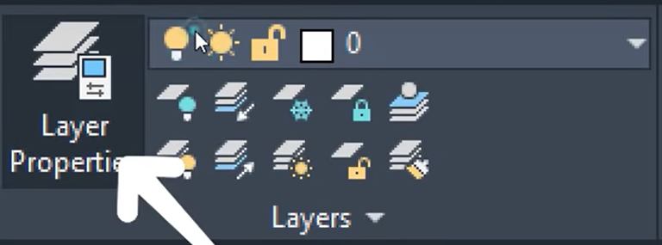

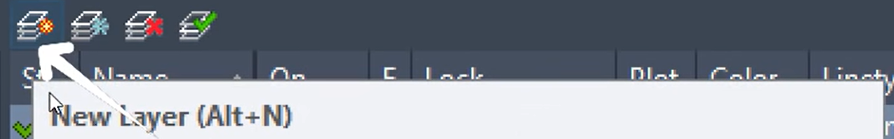

The ideal layers of a drawing are given below

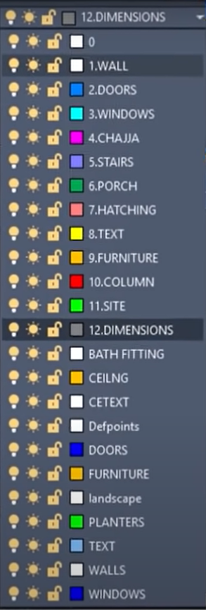

First, we make layers.

For chajja, linetype will be hidden.

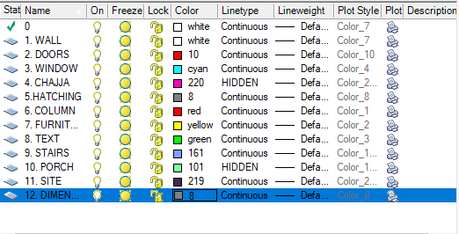

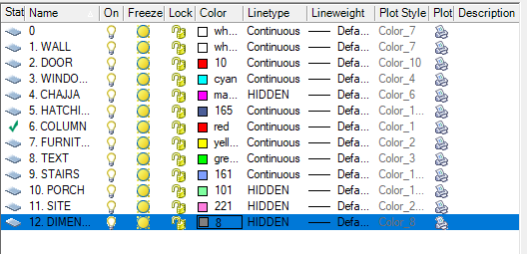

For the wall, line weight is set to 0.35mm,

These are the settings you can use for making drawings.

First, make a rectangle for the plot. The plot is 60’ X 50’.

Now creating the setback distance.

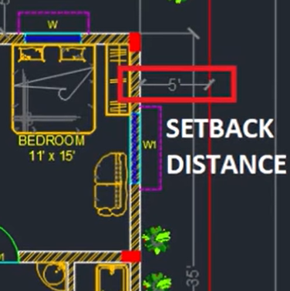

In this drawing the setback distance is 5’. Setback is generally made for entering air sunlight etc.

In front, the setback is set to 10’. The plot color line is changed to red. The white one is building the boundary.

From the building boundary, we need to take the external wall thickness which is taken as 9”.

This can be taken as an offset of 9”.

Similarly, the interior wall is made 4” to 6”. Here we will take 6”.



As seen in the picture below

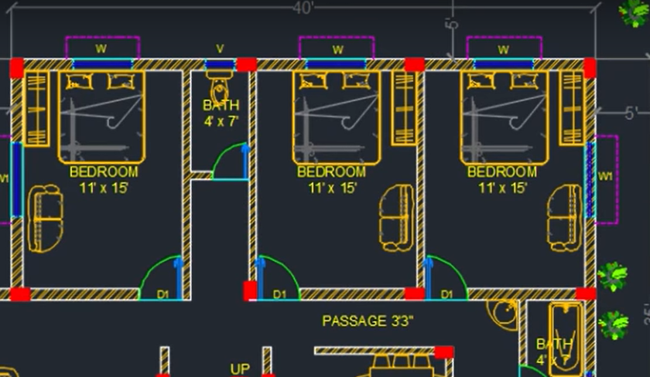

The bedroom length is 11’ X 15’. So, the offset need to take is 11’. Then again the offset need to take is 6-4” for interior walls.

So, the rooms are taken as the diagram shows.

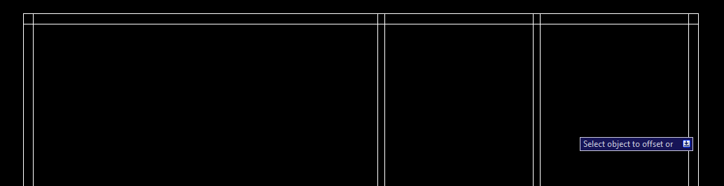

Now we need to take the bathroom that is 4’.

After taking all the dimensions of the rooms and walls now trim the rest of the line. For that, you can use the TR and single enter. Then take the boundary given in the picture

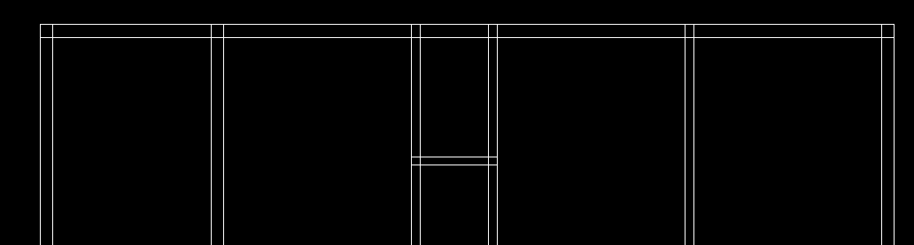



Select the bathroom portion joining which is marked above then press enter. Then rest of the line select remove. It takes the bathroom walls as a boundary and the rest of the line can be deleted easily. Also, you can use TR then double enter then you have to manually remove lines from every room.

Now for another (Living rooms) rooms

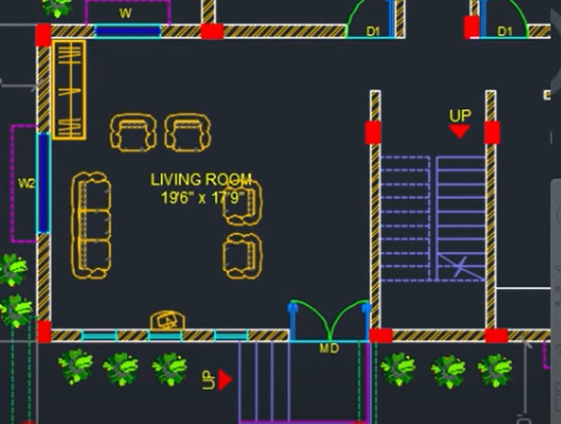

The diagram shows that the dimensions of the living room are 19’6” X 17’9” so let's make it. We can make it by using offset.

After making that now we can make the staircase which is given 6’6”. We can make this by using offset.

After making staircase now we will make kitchen.

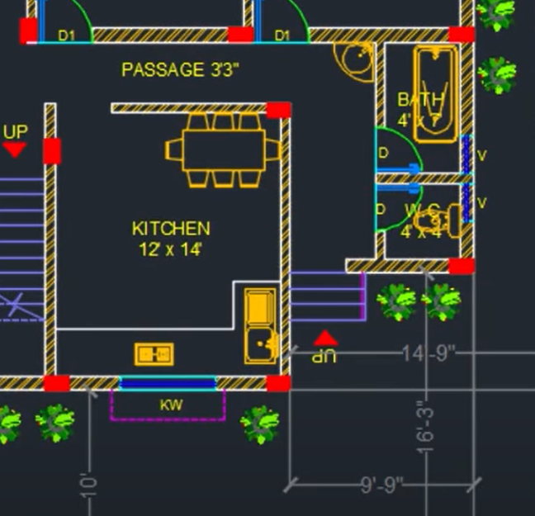

For the kitchen, it is shown the dimensions of the kitchen is given 12’ X 14’.

After completing all the rooms this will look like the below picture of the building drawing. This drawing also needs some doors and windows which will make now. 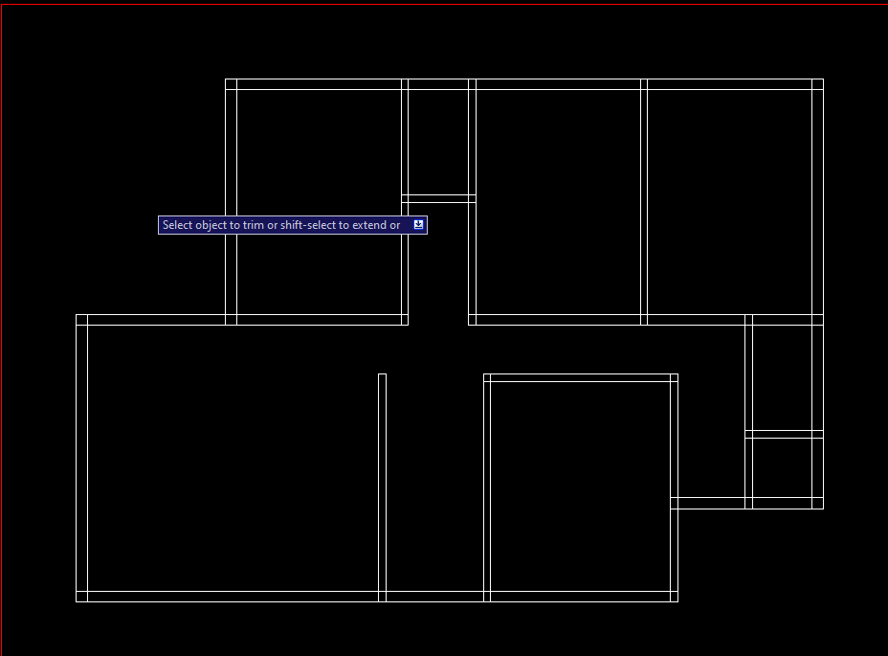

**Door and window size need to be known for making doors and windows of a room, kitchen, bathroom, and WC.**

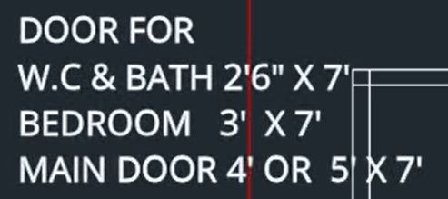

After providing all doors the diagram will look like this

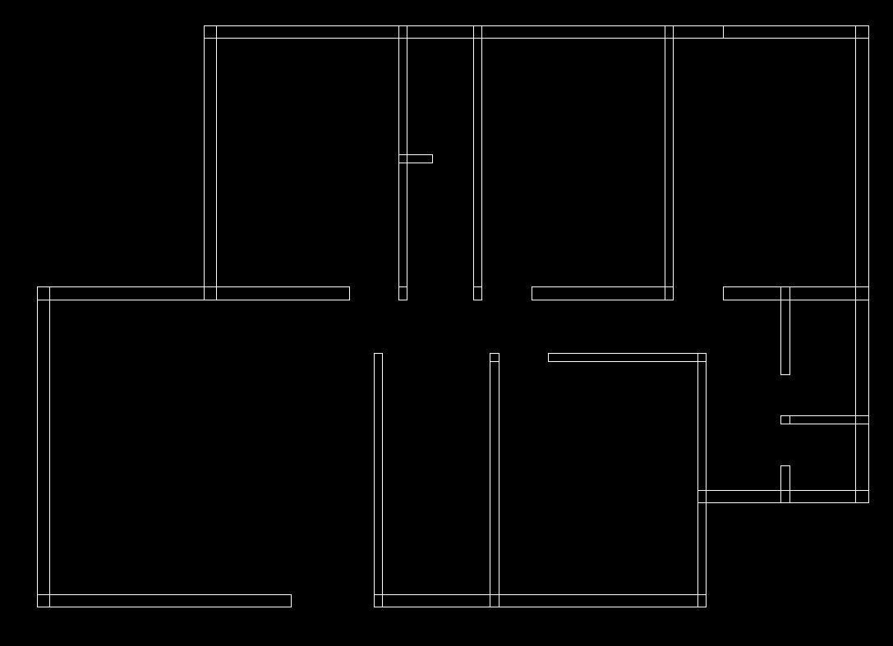



In the red marking it will be a main door of 5’, the kitchen in the blue marking, we will not provide any door in the kitchen but we need to provide a door-like space for entrance. Which will be 3’.

Before adding windows, we need to trim the rest lines because the windows comes in the middle and if we do not trim the lines then the window placement will be wrong. After trimming all lines, it will look like this.

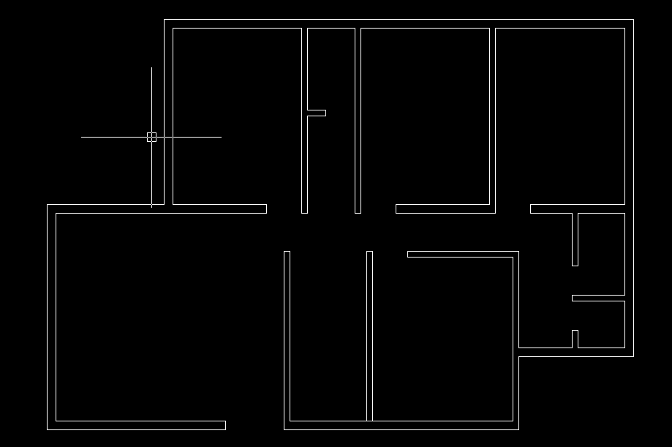

After making places for doors, now we will make windows. Generally smallest window size is 3’ but here we won't use that. Here we will use at least 4’. These windows we will make these outer from the plan and after making all things then copy the drawing to the specified places.

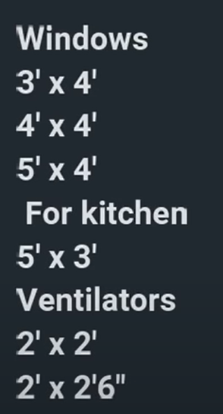

These are the dimensions for the windows.

For making the windows first change the layer then make a rectangle.



This is the dimension of the rectangle.

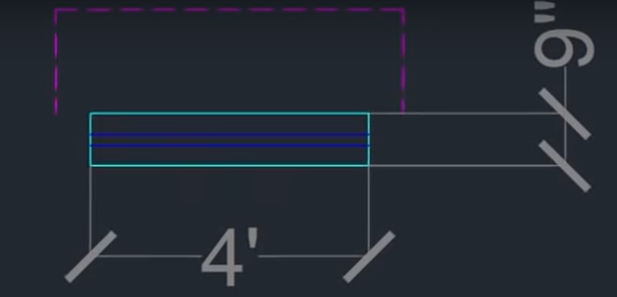

These are the dimensions for the windows in the main walls because the main wall thickness is 9”. After taking a rectangle take a line from the midpoint then take an offset of 1” in both the upper and lower direction.

After making the front windows we will make a chajja in these windows to complete the copy-paste process. For chajja, we will use a polyline and change the layer to CHAJJA. For chajja we know that the size of the chajja is bigger than the window so, we will take 6” extra in both sides and the length of chajja will be 1’6”.

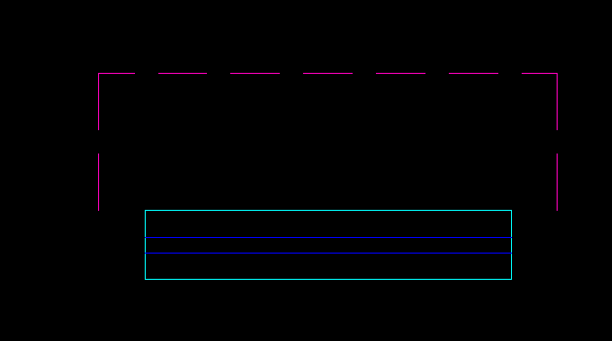

After making it look like this. After that save this into block () which can be found on insert. If you make a symbol and you want to use the symbol multiple times then you can use that symbol in your plan multiple times and new plans as well. For making select the symbol (here window + chajja) then select create, then name appropriately, then click to pick point and select pick point (here midpoint). After making the block then copy the windows and make different lengths for different rooms. Here, 3 windows will be needed. First will be 1.2, second will be 1.5, and 3rd will be 1.8.

For changing the size of the window, we FIRST need to explode the block (using command ‘X’), then we can change the dimension (Remember first we need to explode this otherwise the block behave like move command). Then we can use stretch command for changing the size of the window and chajja. For stretching the window, first click the stretch then half choose the window like shown below.

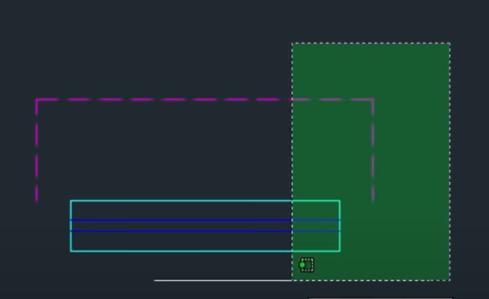

After pressing enter we can stretch the diagram like this

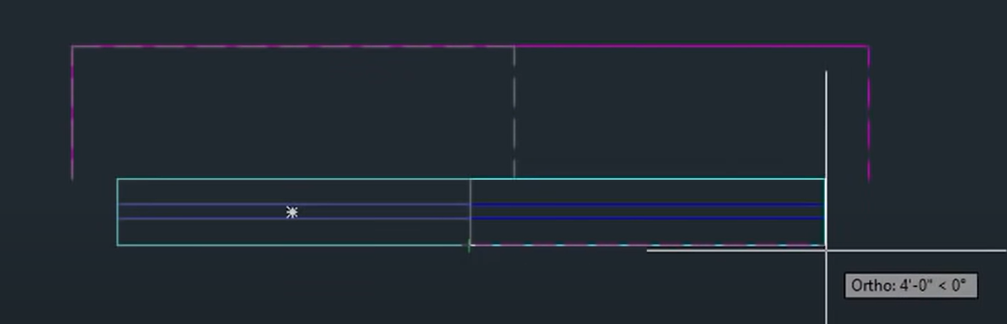

Give the length for stretching. (if I use 1’ then the length will increase by 1’ more this is the equation). Make the new windows into the block. Then if needed, rotate the windows according to your requirement. For rotation, select the blocks/windows, then press ‘RO’ which is shortcut for rotate, then set the base point. You can use any point as the base point, it helps to rotate the objects with the help of that line. Then we can use the mirror command for using the windows as inverted direction. For that, use the command ‘MI’, for mirror, then choose the axis. Just remember if you don’t need the source object then you can delete(Here we need the source object so we choose the NO option). After making all the things, then copy paste the windows in the places need. After making the windows in the building.

In the lower portion there are three glass windows needed, for that you can make windows and then paste it here or you can make directly the windows. For that, you first change the layer to windows. For that make a line then offset that line of 2’ and make 3 glass windows in that portion as shown below.



Like this. In addition, load this in the block for future needs.

Also, we need ventilators in portion which is given the image



First, make a line in mid portion, and then take 1’ offset for length of the ventilator in both sides. Then take offset of 1” upper and lower as made for the windows. After making this ventilator, convert the ventilator into block for future usage. In addition, this ventilator we will use in the portion where necessary.

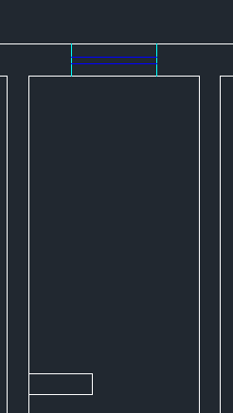

In this two portion ventilators are necessary, as these are the bathrooms and WC.

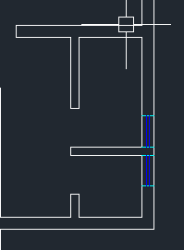

**Staircase**

For staircase, we will use the places that are assigned for the staircase.

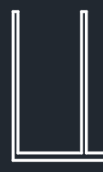

First we need to make landing, for landing we can use the offset of 3’ which is the minimum landing length. After taking landing, it will look like this

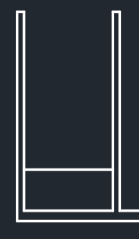

Next part is to make stairs. Make sure to change the layer of landing to stairs as offset from the wall so that the layer made is the wall layer.

For stairs, we can again use offset. For stairs, the tread is 10” for each tread. And make 10 rises. After making the stair it will look like this

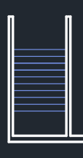

Now take a line in the middle and stairs are ready. After making full stairs it will look like this

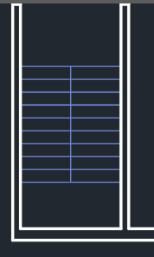

After making this we need a gap in between the stairs so we can make a 3-inch (3”) offset in both side and trim the mid portion. After making this the stair will look like this.

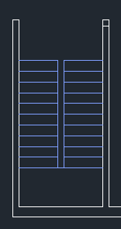

Now we can draw the staircase for verandah.



Here will be staircase for verandah. For that, we can take line from the edge and draw. In all direction (5’), the landing distance will be 5’. After taking the lending, the image will be like this

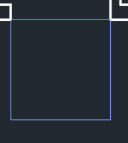

Now we need to take offset for tread. Here we will use 1’ tread. We can take 3 tread and join them with a line.

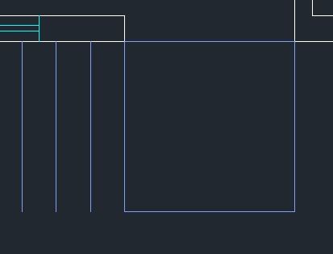

Like this

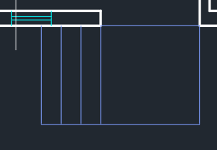

For railings, we can take offset of 2 inch (2”) and trim the places that are unnecessary and change the colour for railings if you need. Here I am changing the colour. After making it will look like this

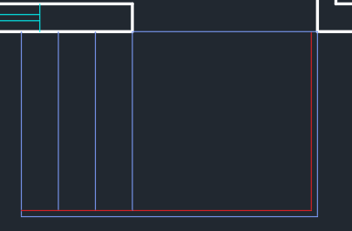

Also in this portion, we will use a staircase. In this portion we need to take a line then take offset of 3’. Then trim the rest of the wall. After that it will look like this.

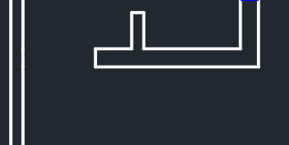

Here also the stairs need to be made as before. Take the offset of the wall of 4’, and take the offset of the stairs of 10” and make it upto 3 rises. Then extend the stairs to the wall using ‘EX’ command as it stands for extend. After making it will look like this

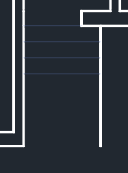

The wall is offset about 4’ and the stairs offset was 10” and the excess walls are trimmed and the railing provided as shown in the figure.

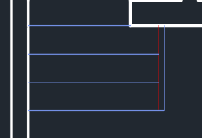

In the staircase, the half staircase is in hidden so making hidden first we need to off the orthomode. In addition, make a sign like the picture which shown below and the rest stairs make hidden and adjust the scale if necessary.

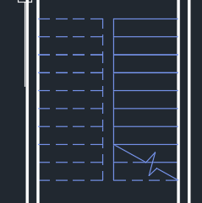

**Doors**

For making doors, AutoCAD already provides a symbol. If you press crtl+three (from the upper numbers of the keyboard) to open tool pallets which can provide the doors symbol. Then go to architecture and you can find “Door-Imperial” which need to be select, and then paste it to outer side of the plan because we need to copy that multiple time and change the layer to doors. This can be helpful to customize the opening of the door and we can set the size of the doors. In addition, we can change the orientation of the doors.

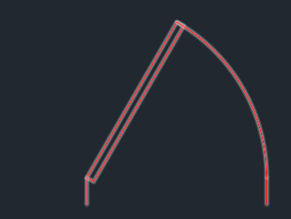

In addition, you can draw block for doors. Dimension for door will be 2” for starting, and then 3’ on the upper side, then again 2” in the left side and 3’ on lower side. Therefore, it will be a rectangle, then make handle for the doors like this (you can take any dimension here dimension is not necessary).

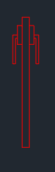

Then take an intersection point of the door hinge and handle outer bar and make a line of 3’ from there. Like this picture

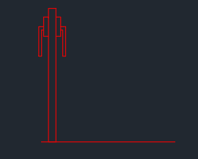

From the both ending, draw a circle (the center will be the center point of the door means the wall portion) and trim the excess points and finally the picture will look like this. Also make this as a block for future reference.

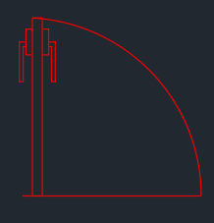

After making, mirror it for making all sides’s door for easy placements.

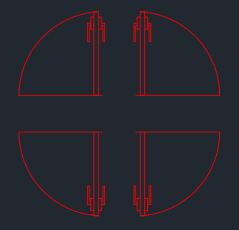

Now this set make a copy and rotate it. It will be easier for placements for all sides.

Now fit the doors in their places.

For the main door, we will use double panel doors.

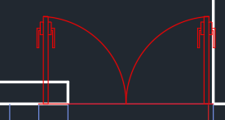

During placement, it can be seen that the doors are intersecting with the walls, so we can resize it. For resizing, select the scale option, select the both doors and select the size icon in the ribbon bar. Then it will ask to define the base point, base point will be the fixed point (which we do not want to change the point) and the other point will be changed (you can use the reference option also. Select reference then first select the fixed point, then the last point of the last door, then go to the place in where you want to put the door and press enter).

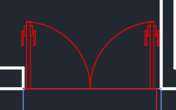

Next is to fit the doors for the bath and toilet. Place the doors and use reference for easy scaling.

After placing all the doors in the plan, it will look like this. Again, put the door first, then the scale option, then click the first point, then press reference(you can press R), then select the first point again, then press the ending point, then pess the point in which you want to put your ending point.

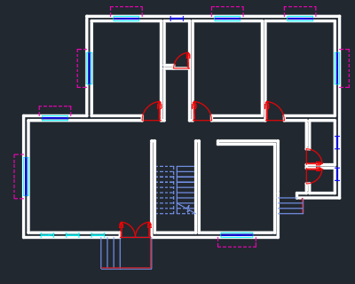

**Texting**

Now we can name the rooms.

For that select the text layer and select the text from the ribbon box by selecting the multiline text. Then select the place in which you want to write and write. After writing, the look of the room be like this.



You might need to place the text in the centered position. You can also change the text size and (here I am giving 6” text size). After that you can copy the text and give the rest of the bedrooms.

After placing the text in the bedrooms, it will look like this.

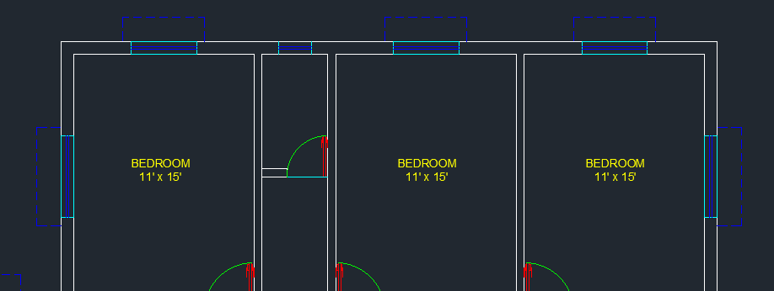

For the lower rooms, copy the text again and paste it then edit according to requirement.

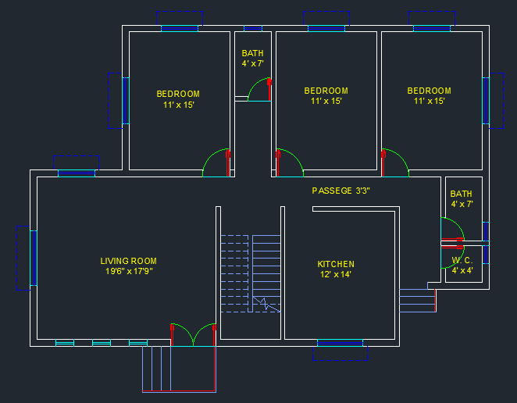

Similarly you can make the texting in doors and windows also. After all the texting it will look like this.

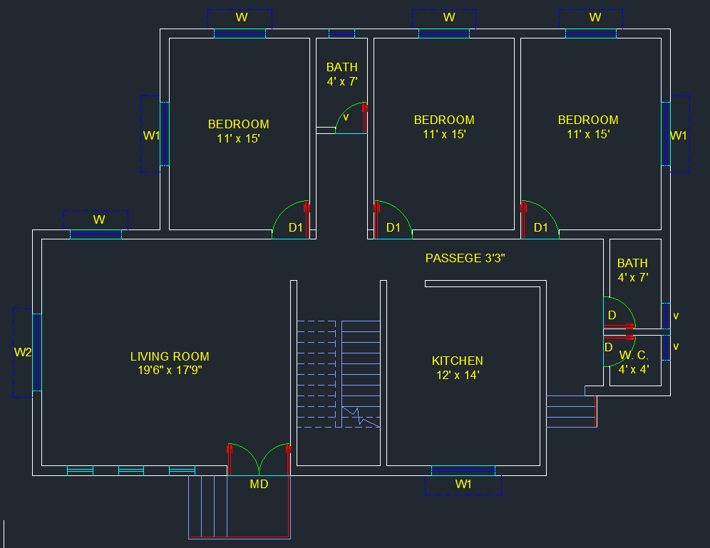

**HATCHING**

The next part is doing the hatching. For hatching, first, we need to choose the hatching. Then choose the hatching icon from the ribbon bar. We need to set the hatching in the walls. For that, then next we need to choose the pattern (here I am choosing the ANS32). Then choose the hatching then simply click the wall portion in which you want to hatch. You need to hatch all the walls in the plan to hatch.

You can adjust the scale in according to your requirement.

After hatching, the entire plan will look like this.

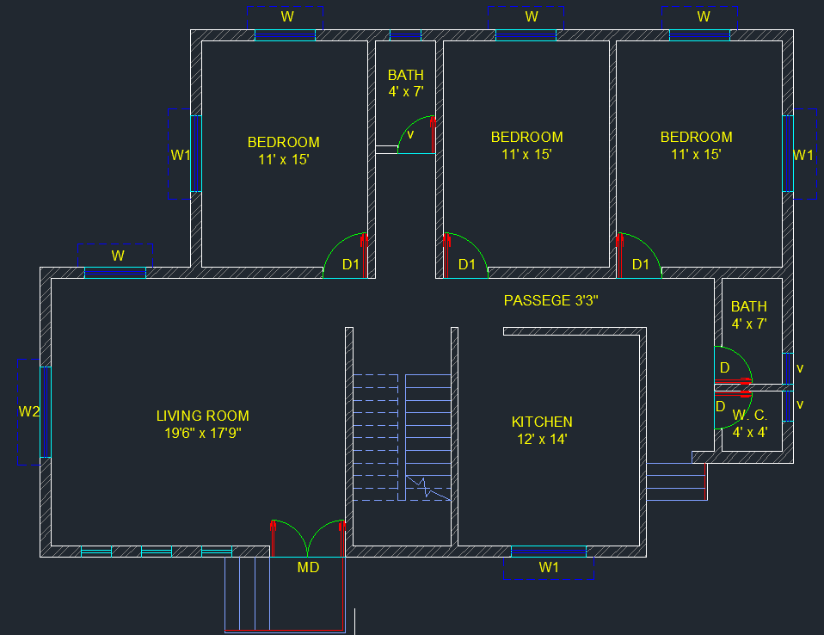

**COLUMNS**

Now we need to provide the columns in the building. For that, select the column layer, then draw a rectangle of the column, (Here we are using the 9” x 15”). Then hatching the column. Then copy paste it to required places. After placing all the columns, it will look like this.

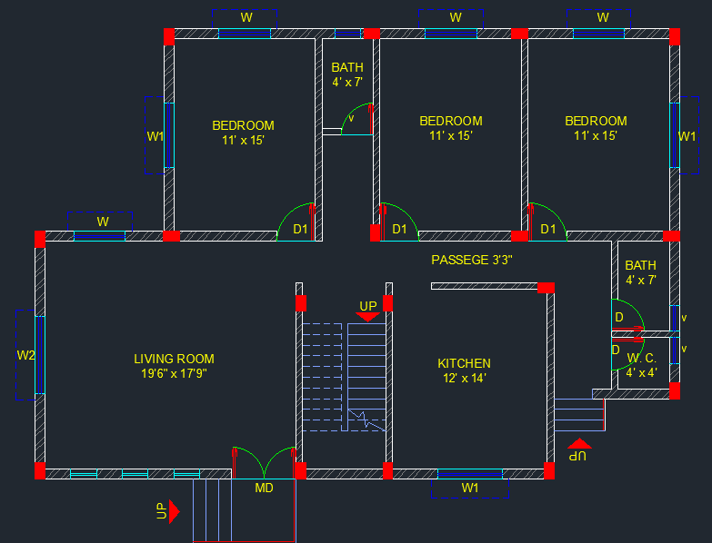

**PORCH**

The next part is making porch, for making porch we can choose the layer porch, then select the pline or polyline, then from the lower left corner, take a 1’6” offset on the backward direction, then again take 1’6” length in the left, then take 8’ line in the front, in the right taken 22’ and then join the line perpendicularly. Then taken 1’ offset in the inner side.

After making porch it will look like this.

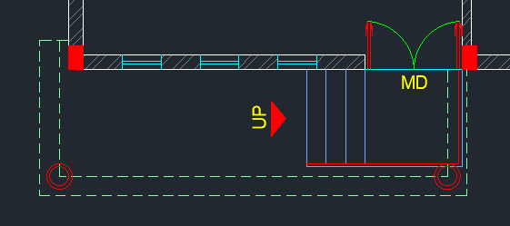

Now we need to make columns for the porch, we will make circular columns in this case, and for that, we need to change the layer into columns, then press C for making Circle, then take 8” circle from the inner right corner of the porch, then take 2” offset in the inner side of the circle. Then copy and paste it to the other side or corner of the porch. After taking the columns, it will look like this

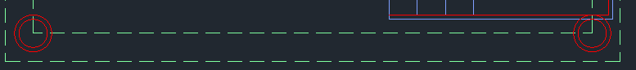

**DIMENSIONS**

The last and final part is, showing the dimensions.

For that select the dimension layer and then use the linear dimensions. First, provide the plot dimension, we need to magnify the text of the dimension, and if the dimension is provided in meter or any other unit then change it according to your usage. For changing the text size, press D then enter, then go to modify, go to primary units, and change the unit format to architectural (Here I used the feet inches length which comes in feet and inches). Then change the precision into 0”-1/4”. Then go to the text portion, and change the text height, to a suitable height according to your need (here I am using the text height 8”). And make the text alignment option into “align with dimension style” then go to symbols and arrows, change the arrowhead to Architectural Tick, and change the arrow size into 6”.

After using all the dimension, it will look like this.

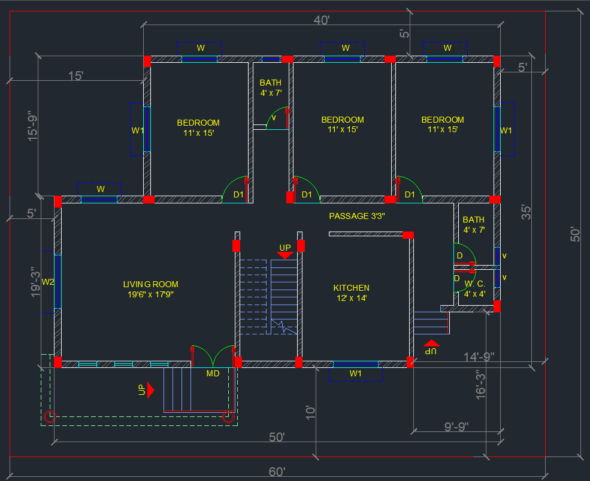

**ELEVATION PLAN**

First we need to make 1st floor of the plan as the above plan is for the ground floor. For that we can copy paste the plan. After making all the nessesary adjustment, the 1st floor will look like this

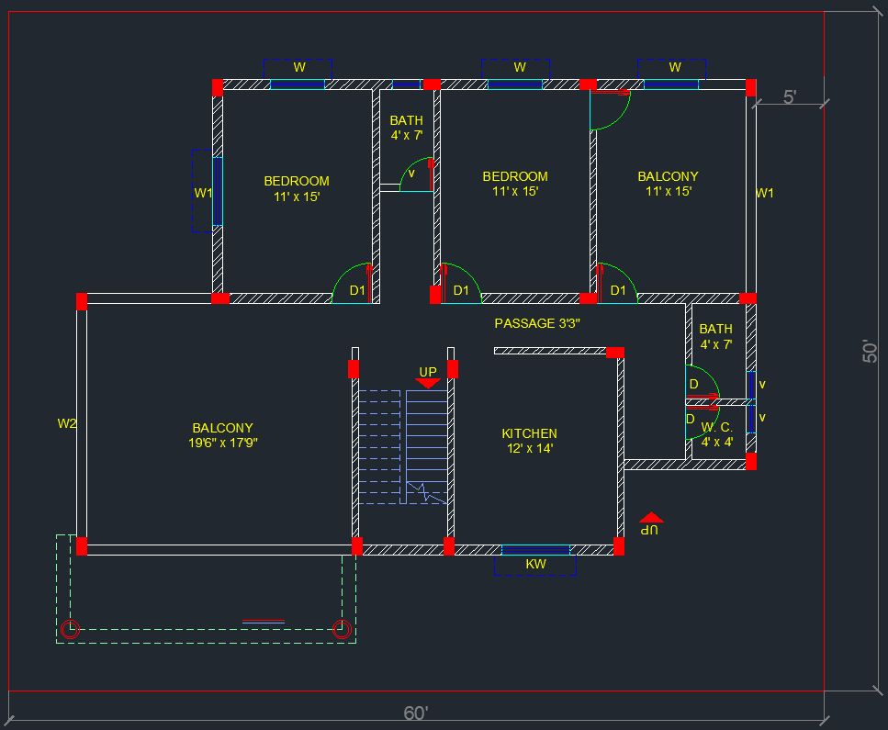

To make an elevation plan, we need projection lines from the first floor. The front part of the floor plan is more important as the elevation shows the front-facing (in this case. We can also make elevations from any side but the front elevation is majorly important for the planning).

We need to think that whenever we make the front elevation, front windows, staircase, window of an internal staircase, another staircase is given that can also be seen, and the porch column will be seen. So we need to take projections of all the things. So first select the wall layer, then we need the projection line, for that we need the construction line. For that, go to draw ribbon, then that portion you can find the construction line

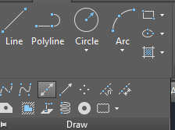

First, we need to draw the plinth with the help of a construction line. In this drawing, the plinth height is provided because we need to go through the staircase to enter the building, so the plinth height is provided. Now how much plinth height is provided that you can define by counting the stairs. Here given 4 risers and one riser is 6”, the plinth height becomes 24” means 2’.

For using the construction line, you can go to draw and then choose the construction line, otherwise, the command will be XL for the construction line.

So XL then enter, then go to command line, then choose vertical, then choose the corner points of the front side of the building (for now).

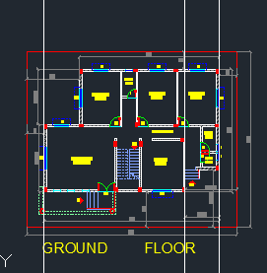

Now we need a horizontal line that shows the ground, for that, we can use a horizontal construction line (XL enter, H enter). Then take an offset of 2’ for the plinth.

After taking the plinth height, now we can make the floor height which is 10’. For that, we need to make another offset of 10’.

After that, we need to trim the external portions. For that TR then single enter then select the portion that needs to be trimmed (it is necessary to take right to left selection for trimming), then press enter, then select left to right, so the external lines can be removed.

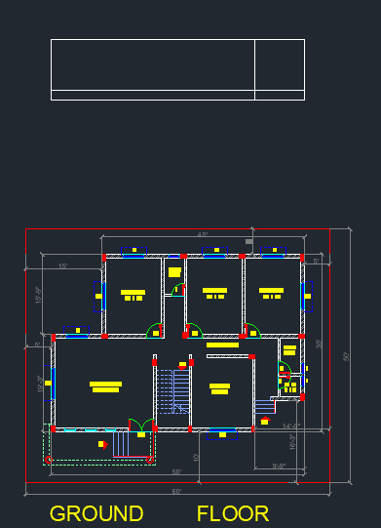

Now we need to make projections for doors and windows. Before taking that, you can change the color of the line, for that you can take another dark color or you can change the layer also (here we are taking little dark grey type color). Then take the vertical projection line, then take projection line from chajja, and doors and windows. After taking all the projection line from chajja, doors, windows, it wil look like this

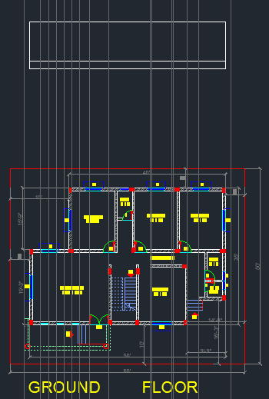

Then we take a horizontal projection line, and draw that with the plinth height, then taking another offset and take it to the 3’ for see height. Then take another offset of 4’ for window size then another offset of 6” for chajja.

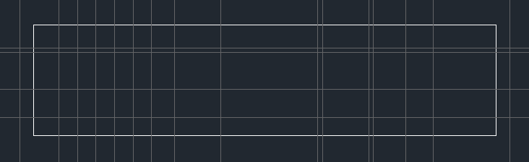

After that, change the color of the layer then draw the windows and doors. For that you can take rectangle as the measurement points are already got. After drawing all the doors and windows, it will look like this.

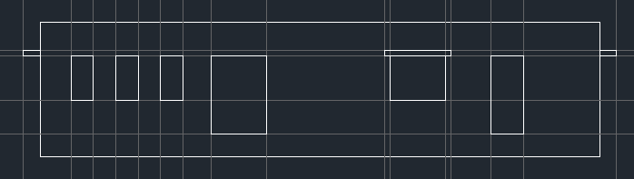

After making all the doors and windows, now we need to DELETE the projection line NOT TRIM.

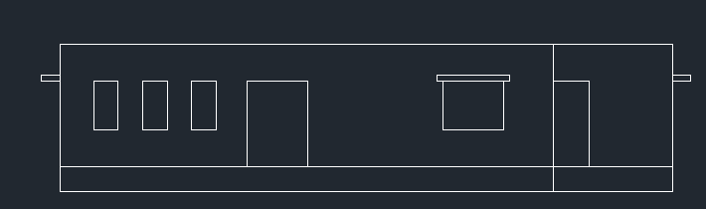

**STAIRCASE PROJECTION**

for staircase projection, we can simply take a projection line for the staircase, like taken before. After taking projection lines, it will look like this (Try to take grey color so that you can differentiate the difference between projection line and walls).

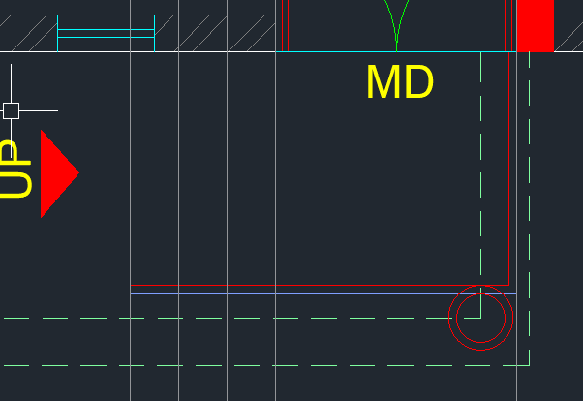

These five lines we need to take

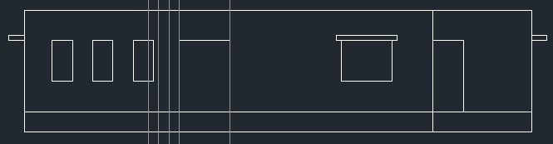

Then take projection line which will draw in the ground level of elevation plan, then take offset of 6” for each stair and the offset will be above from the ground level.

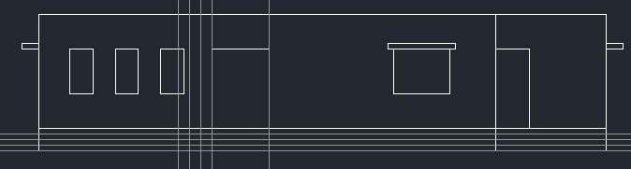

Then change the layer to by layer then take L for line, then draw all the stairs like this.



Similarly take another staircase projection line and make the stairs.

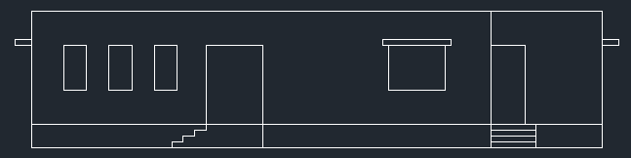

Now we need to make the first floor similarly like the ground floor we made. Plan of 1st floor is given

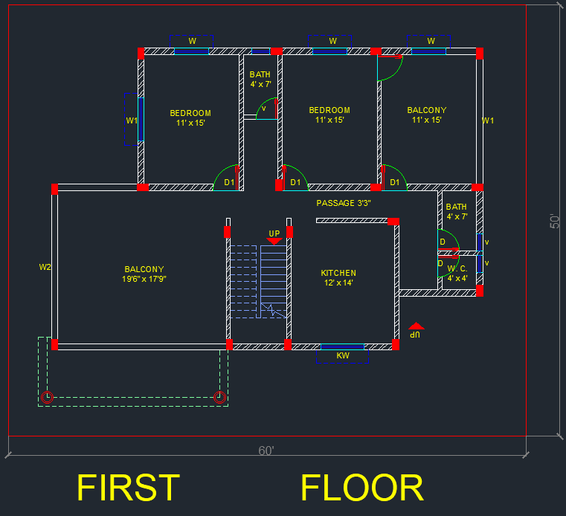

Here you can see in the front side balcony portion available, here a paraphet wall will be needed. Generally, the height of parapet walls will be lower than the general wall so the bedroom wall will be also visible. So, we need to make elevation keeping in mind that portion also.

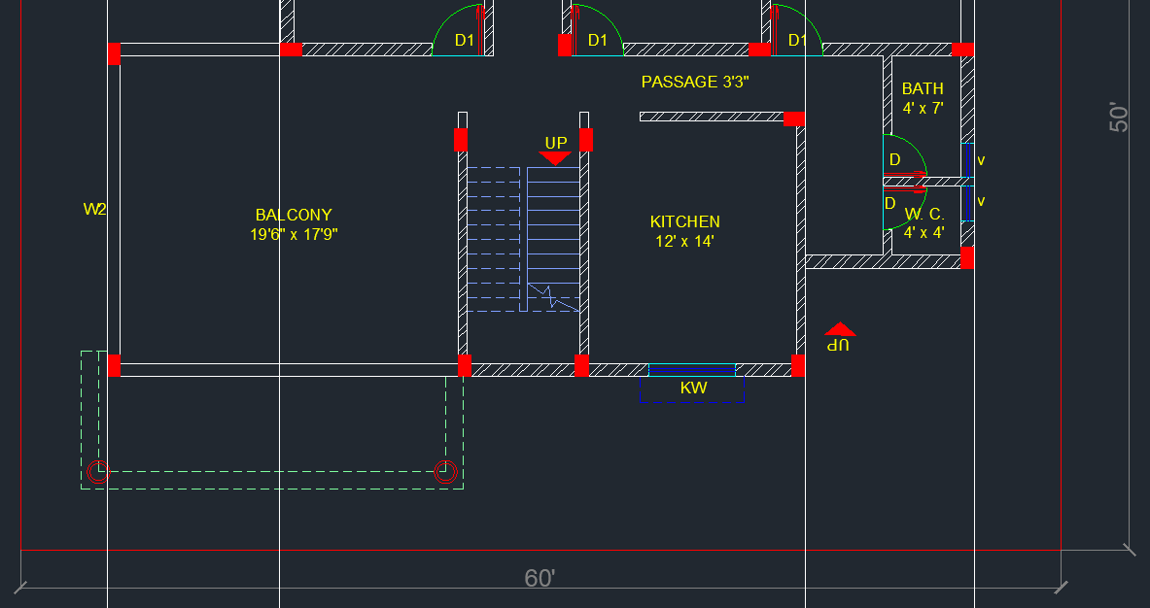

These four projection lines will be needed for making the first-floor elevation.

Then take XL enter H enter then use the line referencing the line of the ground floor elevation plan. Need to remember that on the 1st floor, we do not use the plinth height. Plinth height is only provided on the ground floor. Then trim the lines of the projection lines.

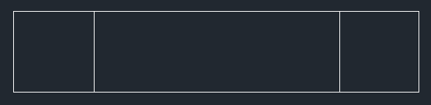

Taking all the projection line for windows and ventilator it will look like this

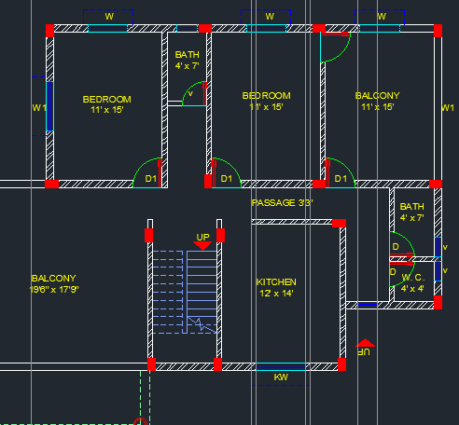

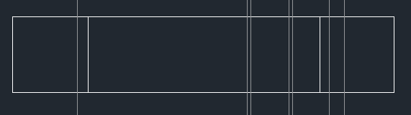

Then take offset for seal height of 3’ from the lower line then take another 4’ offset for windows and then take 6” offset for chajja. Then change the layer to by layer then make the windows and chajja. And make the parafet line. After making all the windows, ventilator and parafet walls, it will look like this

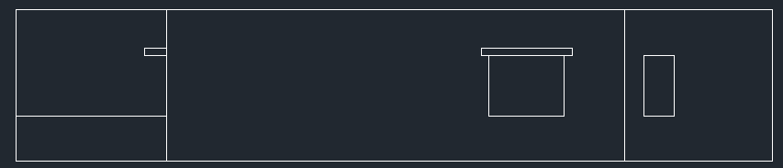

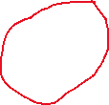

Now these two lines need to be remove as in the 1st floor provided balcony. After removing these lines it will look like this.

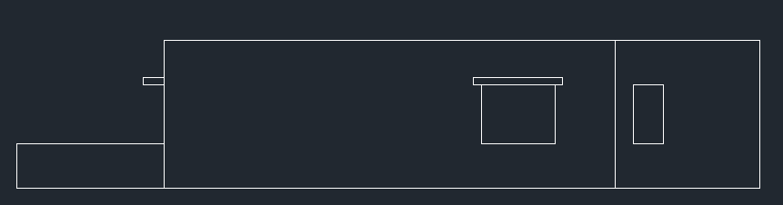



One more line projection we need to make that is the projection line of the stairs. And the balcony line needs to drag through the wall. For balcony the above wall needs to be trimmed.

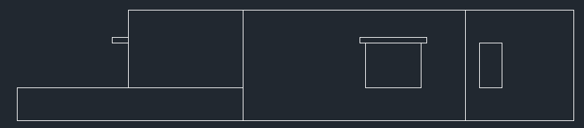

Now the entire first floor elevation needs to copy and paste it to the upper side of ground floor like this.

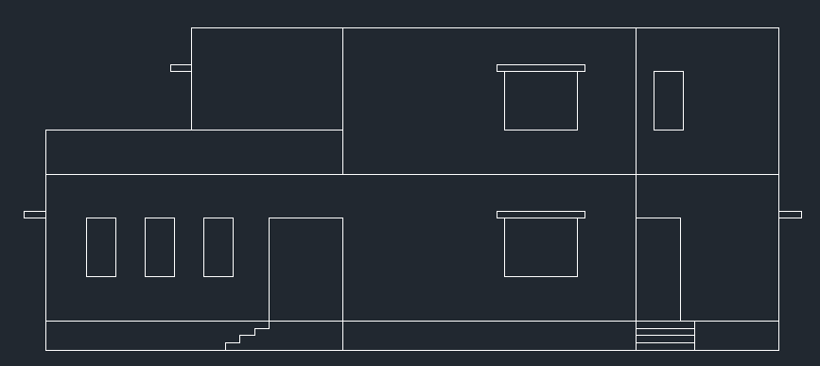

**PORCH ELEVATION**

For making the porch elevation, we can also use the projection lines of porch. For that select grey colur, then make projection lines from the corners of the porch like this

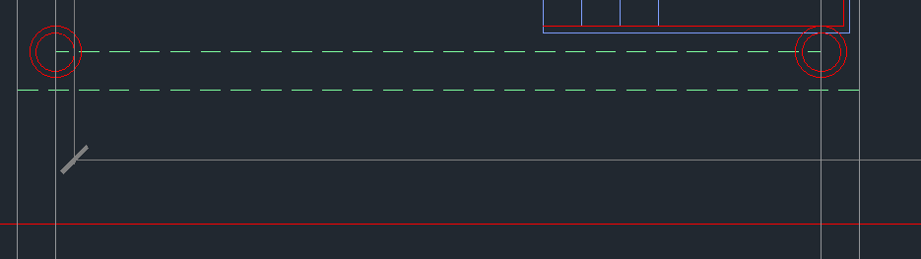

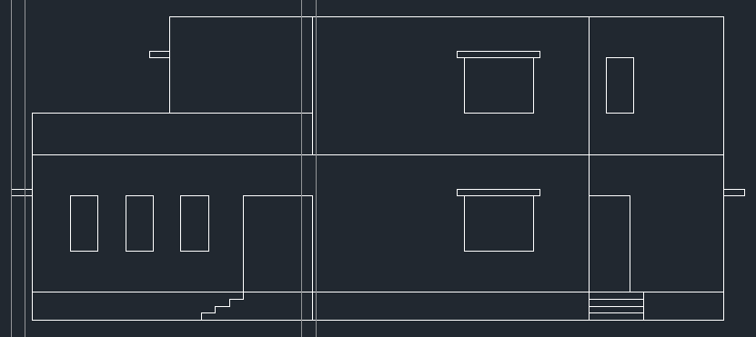

Then take horizontal projection line in the plinth height, then make 8’ offset of that line, then make two offset of 6” (Porch thicknesss) after that height like this.

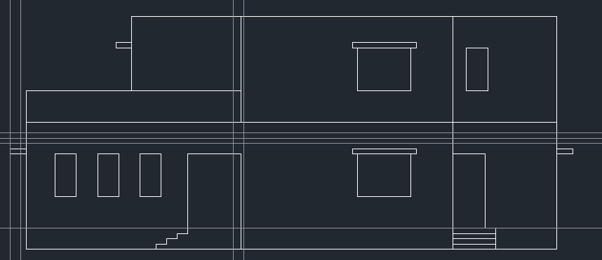

Now, change the layer, take a rectangle, then draw the porch like this. Then remove the projection lines.

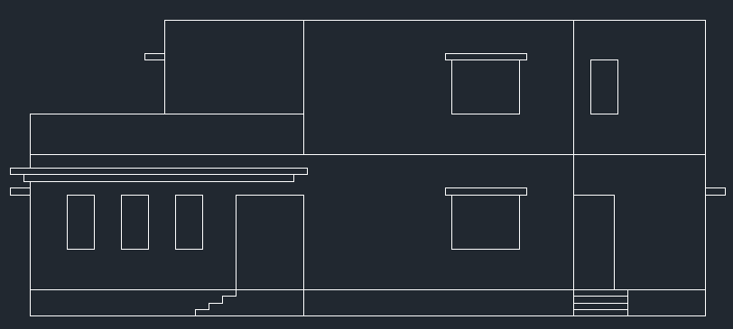

Similarly we need to take projection line of the columns

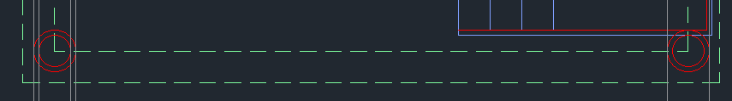

Then go to the elevation, then make a rectangle to the inner side like this

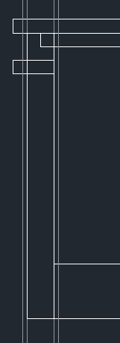

For the lower part, make a rectangle like this

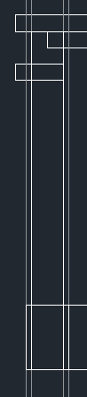

Now delete the projection lines and trim the lines which comes behind the column.

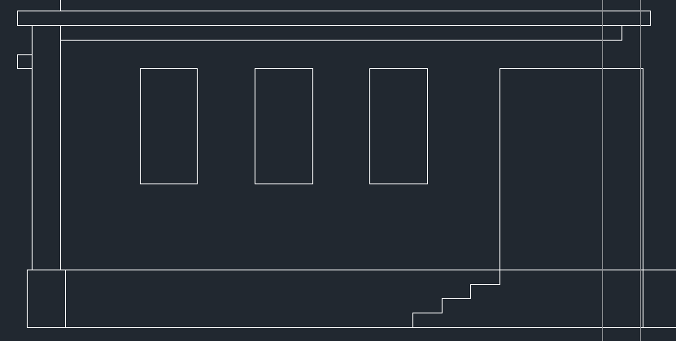

Now this column copy to other side also.

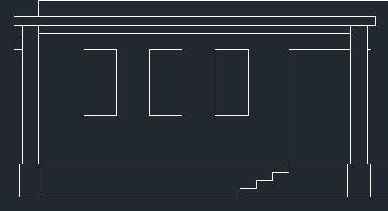

Now we need to draw the terrace parapet walls

For that, we need to offset the upper line to 3’

Then extend the lines like this

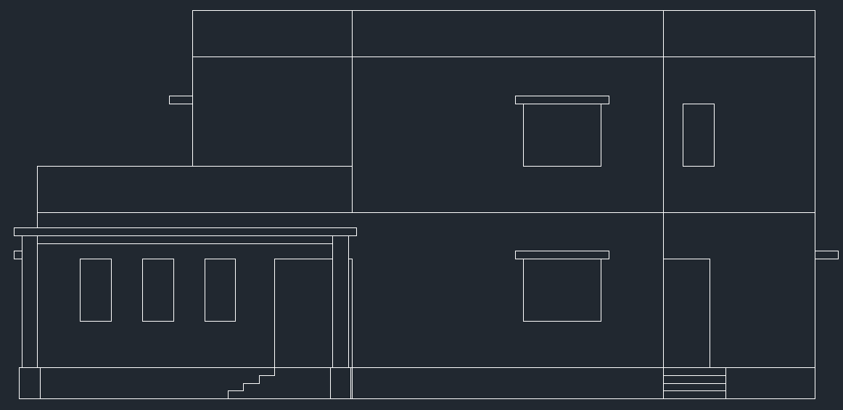



Now we need to make the frames of the windows. For that, we can see in the above picture that the red colored marks is for the kitchen window. We need to lower the height of the kitchen window, for that kitchen window height is generally 3’ but the above window height is 4’ so we need to decrease the height of the window. For that, select the rectangle and decrease the height 1’ like this

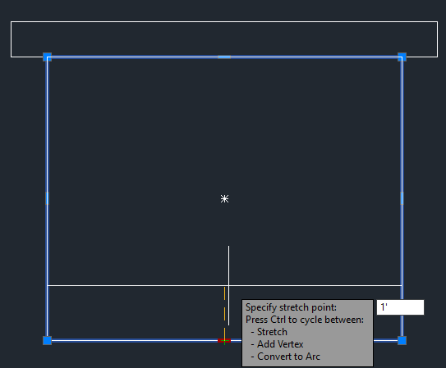

The above kitchen window need to make of 3’ in the same manner

**FRAMES**

For drawing the frames, we can take offset of 2” for the glass windows.

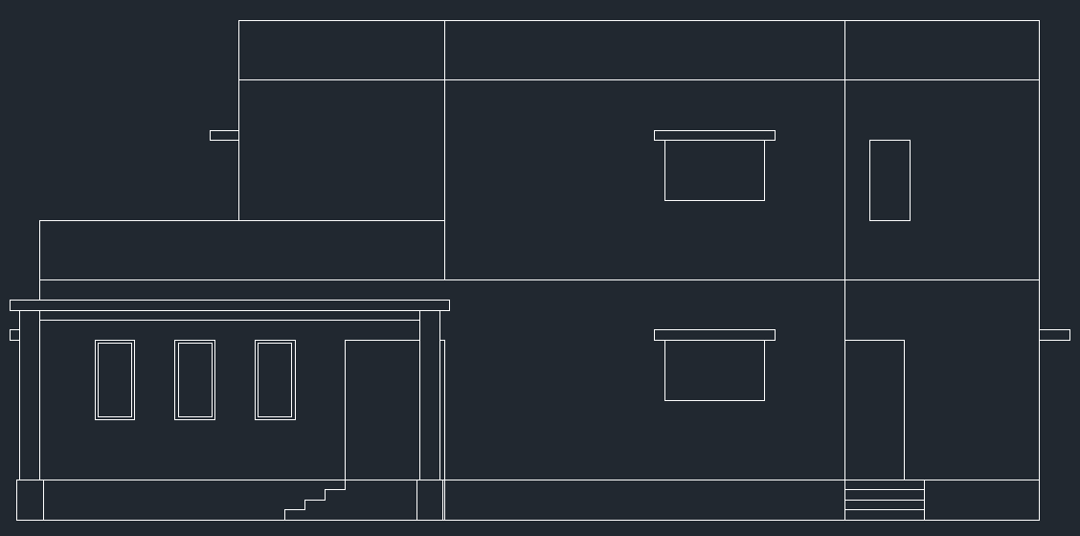

We can use glass symbol in the glass windows, for that turn off the ortho mode, then make lines like this.



Then select all the lines and grouping them using G command. Then copy and paste it two times of the same window. Like this.

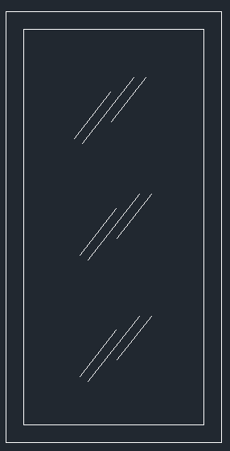

Do this in a same manner in the rest of the glass windows.

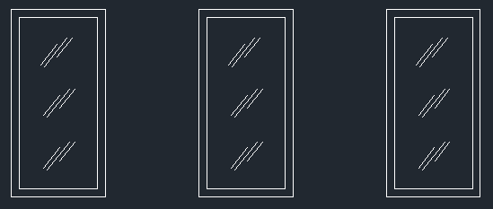

Now you can provide color on the glass windows, here we are going to do hatching, then gradient hatching, then choosing deep blue and light blue, then paste in the windows, like this.

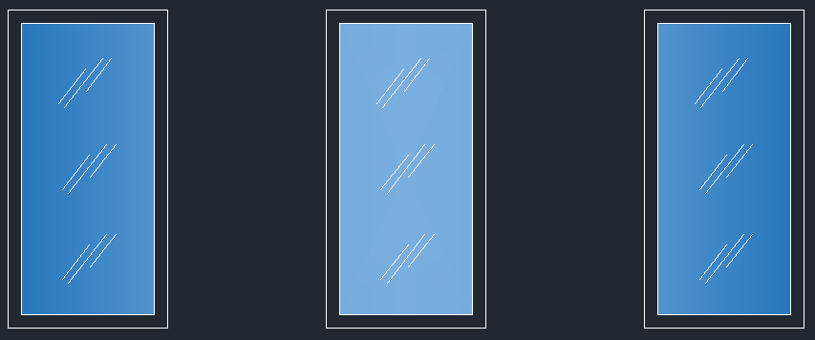

For kitchen window, we will use the sliding window. For that, make a 2” offset, then draw rectangle, first point provide any corner point and end point will be mid point like this

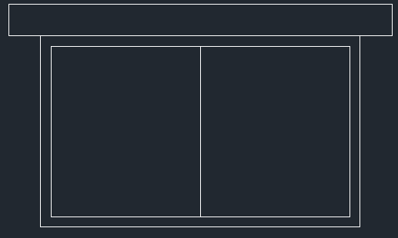

Then offset the rectangle (new made), of 1”

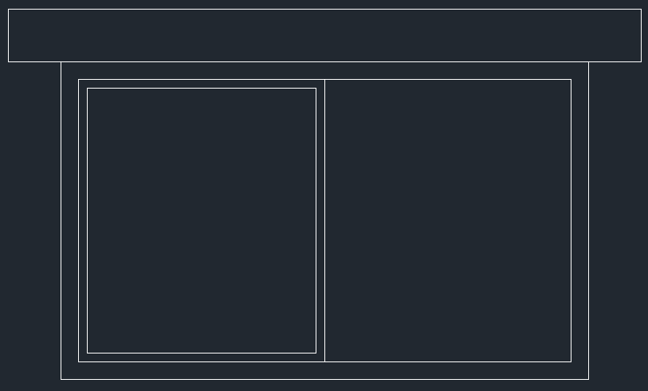

Then copy and paste it to another side.

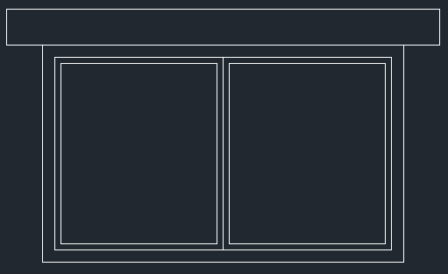

Then copy the glass symbol and paste it to the windows as well. Then drag it accordingly.

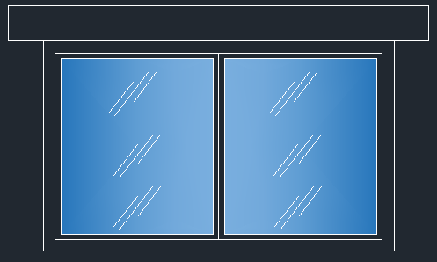

Then hatch it like similar manner. Copy the window and paste it to the upper window as well. Using this same manner you can draw windows.

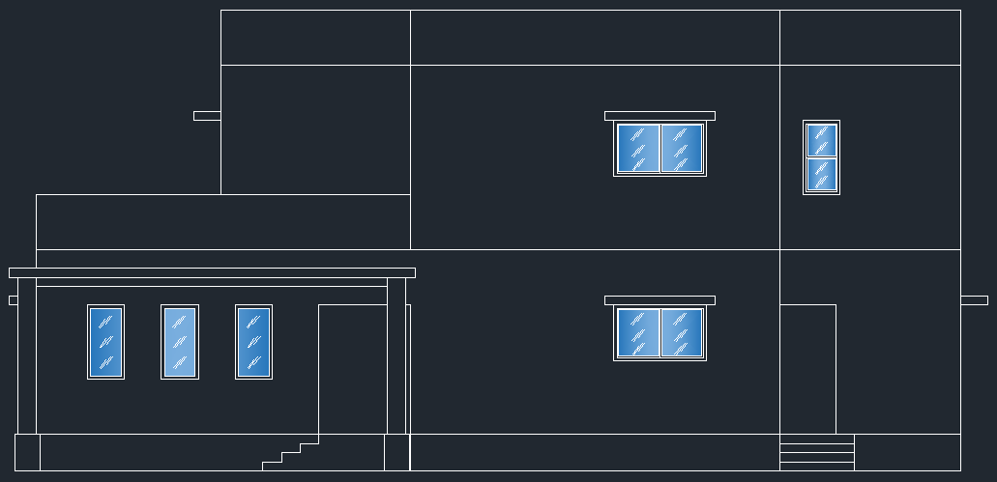

For doors, we need to take an offset of 2”, and then trim the lower line because the lower portion does not require offset. Then extend the lines of the left and right sides.

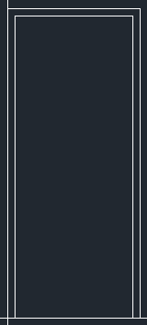

Here we can make a symbol for doors for that, making a circle in the middle, and then making a line from corner to tangent like this

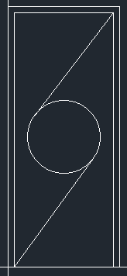

For front door, we can make an offset of 2” then making double pannel doors, for that, making another rectangle, then taking offset of new window of 1”, then making door like this

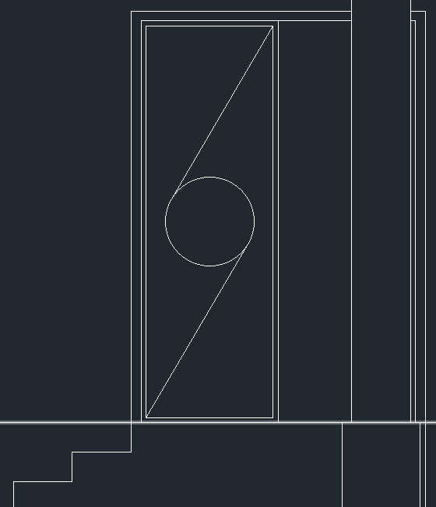

Now we need to draw headroom for the staircase. For that, we need to take the construction line from the exterior walls and windows of the stairscase like this

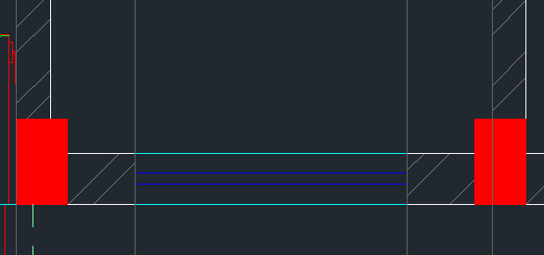

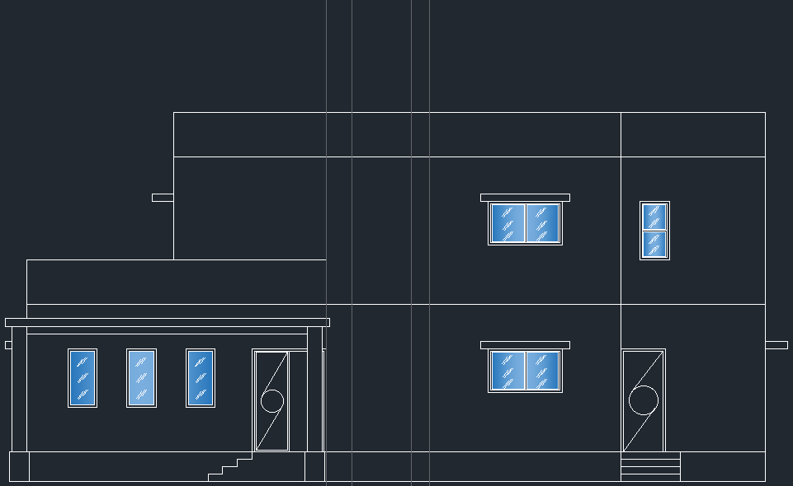



This portion will be our headroom portion, now we need to offset the lower marked (blue) line to 8’ for headroom, then 6” offset for slab. Then draw rectangle for the headroom portion (don’t take rectangle from the 6” slab offset. Take rectangle from the line below 6” offset) like this

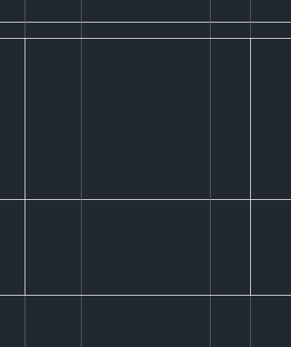

After that, provide offset of 1.5’ on both side (take projection line offset) for extra slab. The final headroom will look like this

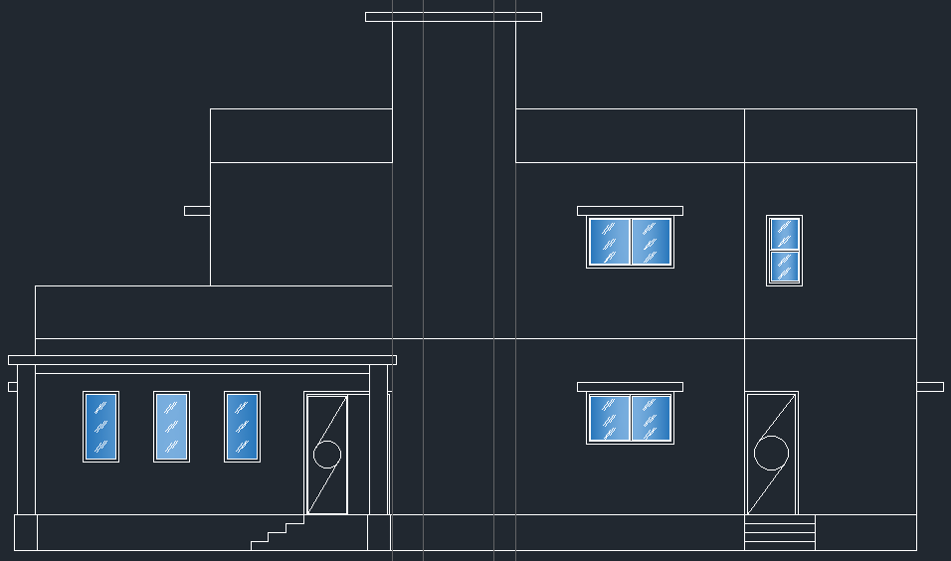

Now we need to make the window of the staircase. For that, we will take an offset of 2’ from the lower line and upper line. Then taking a rectangle, then we can make this glass layout. For that taking 2” offset of the rectangle for framing, then midline, then again midline horizontal wise. Like this

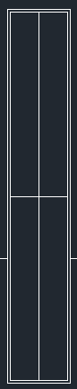

After that taking a rectangle of the above part, and making another rectangle of half of the above rectangle like this .



Offset the above rectangle of 1”, then provide the glass symbol then copy the whole and paste it to the lower rectangle like this

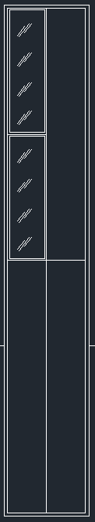

After copying all windows and providing gradients, it will look like this.

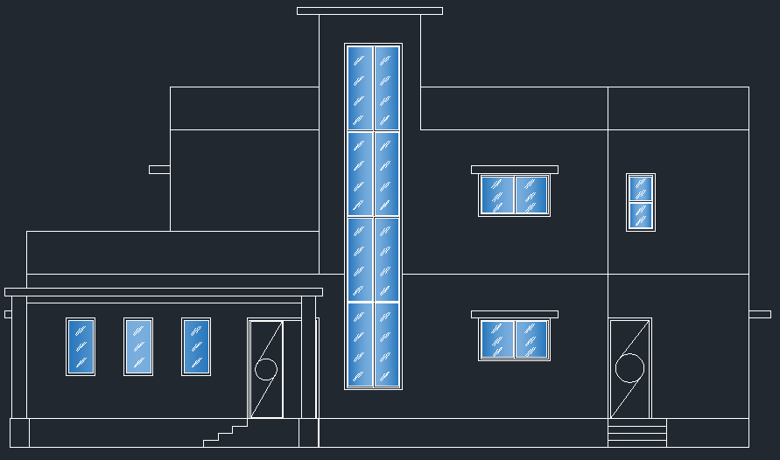

Next step is providing the symbol of ground

For that, we can make like this

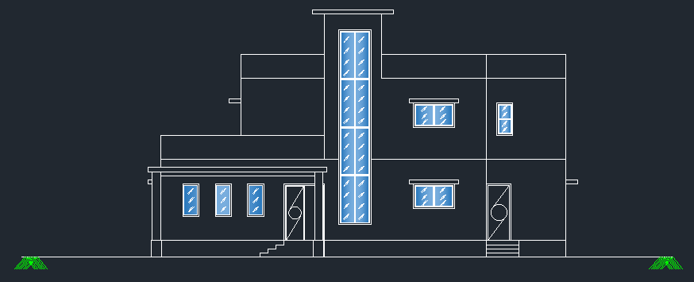



We need to show gravels for the plinth, for that, go to hatching, then search for gravel, and then provide the gravel hatch for the plinth portion, in these three portions (marked above). After adjusting scaling for vision improvement, adjust color (Here we used grey). After that, for the stair portion, we have to hatch with the concrete layer (‘AR-CONC’ is the name of the layer), for that, we can use concrete hatching (here I am used honey comb style). and applying gravel, it will look like this:

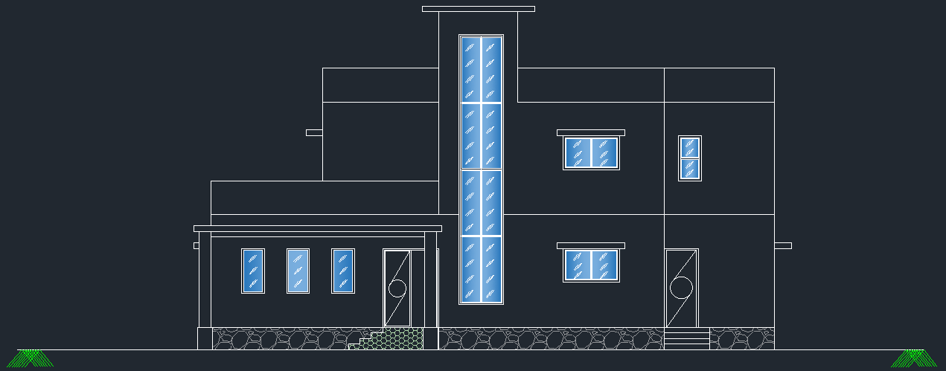

Next for the column, we provide round column here, and for that, taking a line in middle in grey colour, then copy that line in two sides like this.

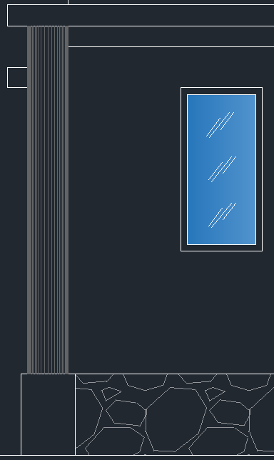

Similarly make the second column as well.

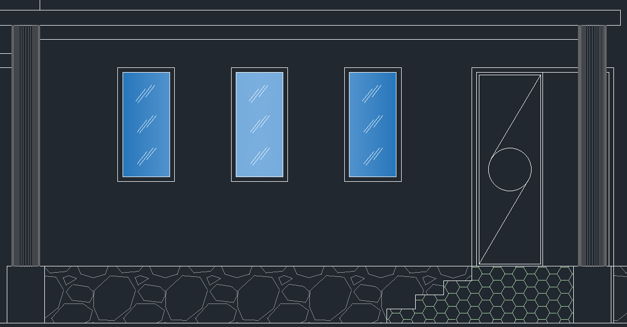



For this lower portion we can make another design like this.

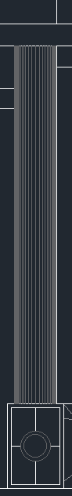

For parapet walls, we can take any hatching colour, here we are using orange colour.

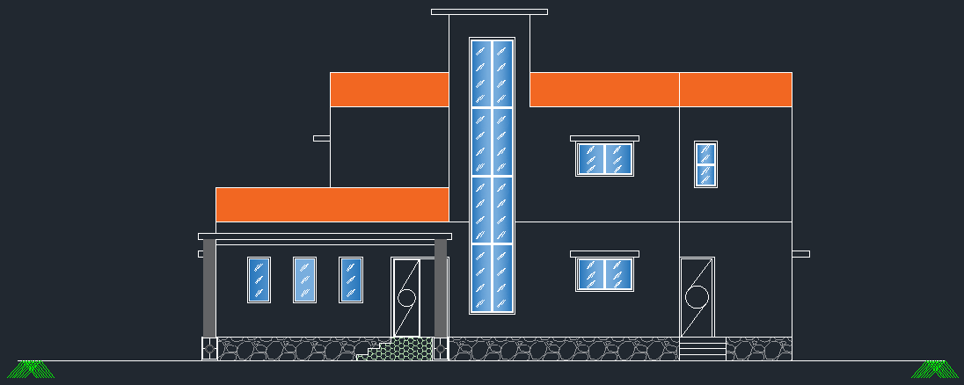

Same for the porch portion

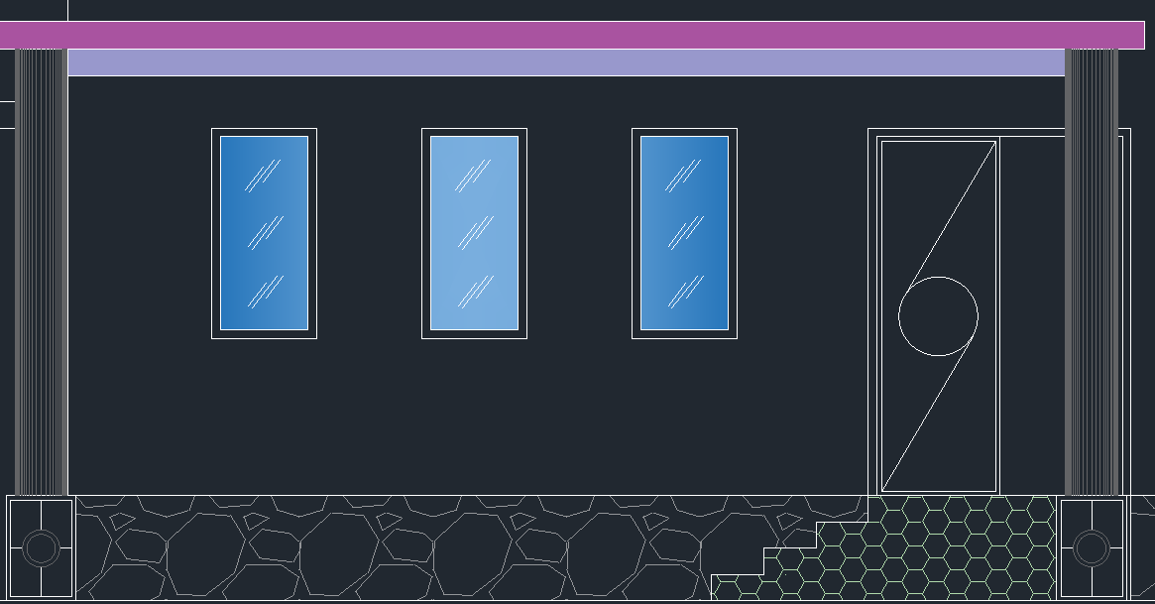

Same in doors,

You can also define some trees in your plan. For that, press ctrl+3 which helps to open the tool pallete. Then go to architecture then trees imperial. Then change the color (into green) and click the trees, to show the arrow mark, then press the arrow, then change the trees into elevation. You can also use vehicle in the same manner also. After applying the trees and vehicle in the porch portion, it will look like this.

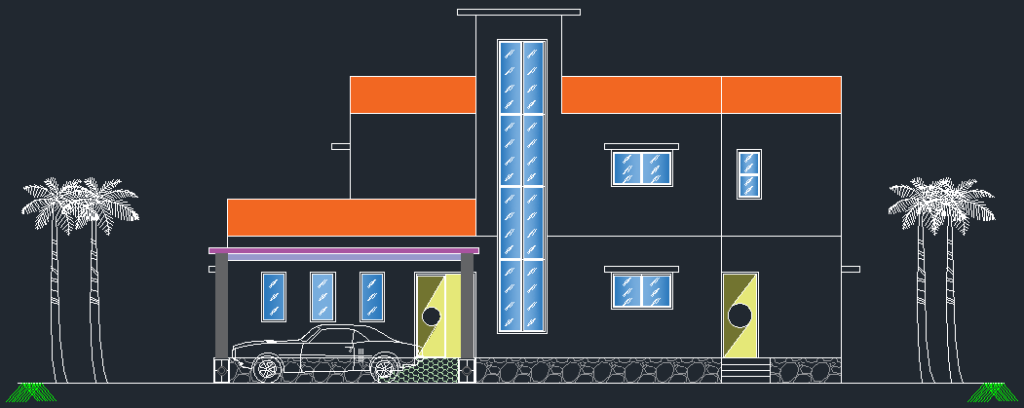

This is our final image of elevation plan.

You can use the dimention in this plan also, for that, first use dimention and provide dimension in one part, then press in the dimention then select continue dimention then extend the dimension to use dimesion easily.

